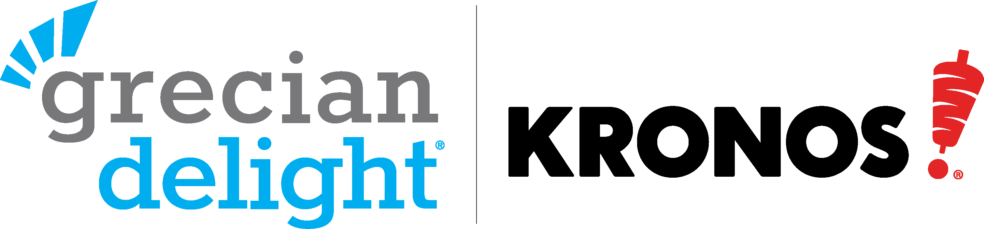

FESTIVAL REBATE OFFER

Grecian Delight|Kronos offers a rebate based on the total number of cases of qualifying products purchased for your event as shown below. Minimum purchase of 25 cases per product category required to qualify for a rebate.

Product Category | Rebate Per Case  25-99 Cases | Rebate Per Case  100+ Cases | Number of Cases Purchased | Rebate Subtotals
KronoBROIL® & ReadyCarved® Gyros Slices | $2.00 | $2.25
Gyros Meat (Cones, PC Meats) | $1.50 | $2.00
Sauces, Dips & Spreads | $1.00 | $1.25
Mediterranean Specialties | $1.00 | $1.25
Specialty Breads | $0.75 | $1.00
Totals

The rebate is payable directly to the event host by Grecian Delight|Kronos upon receipt of proof of purchase (copy of distributor invoices) accompanied by this form for all qualifying cases purchased. Please allow 4-6 weeks to process rebate. This form must be signed and authorized by a Grecian Delight|Kronos sales representative.

Event Host: ________________________________ Check Payable To: _______________________________
Address: __________________________________ City/State/Zip: __________________________________
Contact Name: ___________________________ Contact Phone #: ________________________________
Contact Email: ____________________________ Opt-In for GDK Email List: __________________________
Distributor: ________________________________ Total Rebate Due: ________________________________
GDK Sales Rep: ____________________________
Grecian Delight|Kronos Sales Rep Signature (Required): _________________________________________

