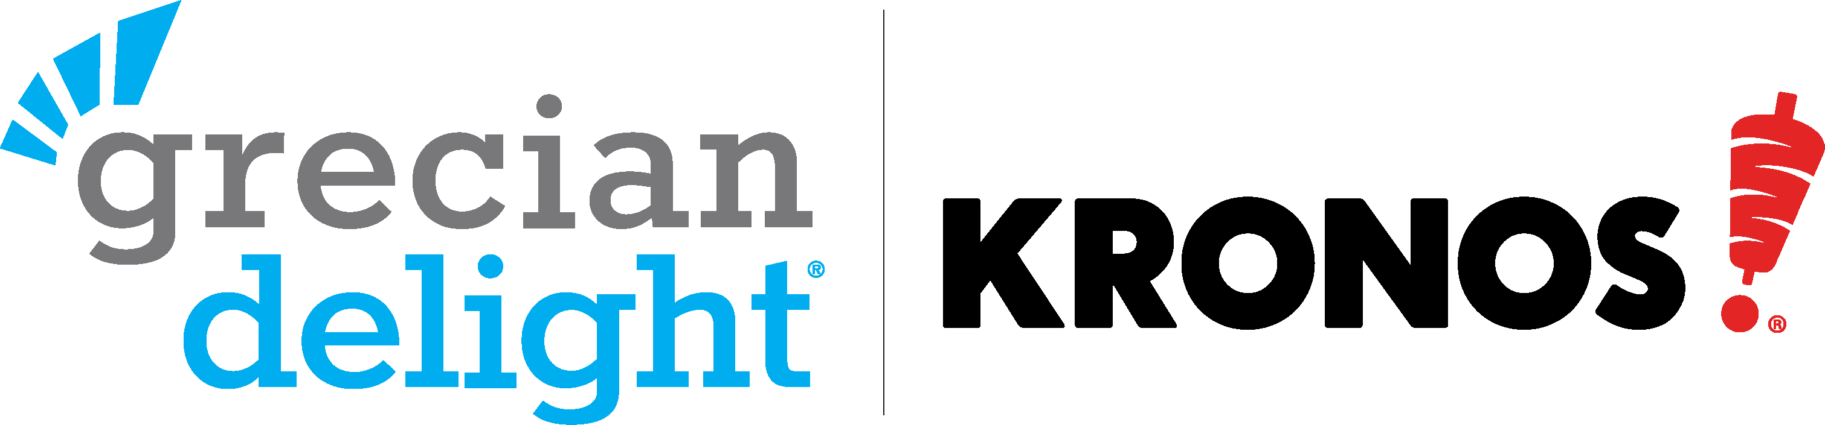

FESTIVAL KIT ORDER FORM

Customer _________________________________ Festival/Event ___________________________
Address __________________________________ Festival Date(s) __________ to _____________
City/State/Zip _____________________________ Contact Phone # _____ ____________________
Contact Name _____________________________ Contact Email ___________________________
Distributor ________________________________ Distributor Phone # _______________________
Distributor Contact Name ____________________ Distributor Email _________________________

Grecian Delight | Kronos Festival Kit Guidelines
- You can get our Standard Festival Kit with a total Grecian Delight or Kronos product purchase that’s more than $500 and less than $7,500. Must provide proof of order from your distributor; 3 weeks’ lead time from receipt of completed form & proof required; while supplies last. Offer open to festivals only.
- You can get our Premium Festival Kit with a total Grecian Delight or Kronos product purchase of $7,500 or more. Must provide proof of order from your distributor; 3 weeks’ lead time from receipt of completed form, proof of order & receipt of high-resolution logo art file & copy for banner required; while supplies last. Offer open to festivals only.
- The Premium Kit’s banner requires that you furnish high resolution artwork for your festival logo. Please note that images pulled from the Internet will not work for enlarging on the banner. 3 weeks lead time required.
- Return completed order form & proof of order to the attention of POS at:
  - Mail: Kronos Foods Corp., 1 Kronos Drive, Glendale Heights, IL 60139, Attn: Festivals
  - Fax: 224-353-5400 Attn: Festivals
  - Email: cmollitor@kronosfoodscorp.com

Grecian Delight or Kronos Foods Product Order Total | Standard Festival Kit |  | Premium Festival Kit |  | Proof of Order Attached From:
$ | Kronos Branded | Grecian Branded | Kronos Branded | Grecian Branded

PREMIUM FESTIVAL KIT INCLUDES:
- Standard Kit PLUS:
- 5 Additional Aprons
- 5 Additional XL T-shirts
- 5 Additional Caps
- 6’ x 2’ Custom Color Banner that includes your festival logo & headline copy
STANDARD FESTIVAL KIT INCLUDES:
- 5 Aprons
- 5 XL T-shirts
- 5 Caps
- 25 Buttons

Grecian Delight Branded POS Items
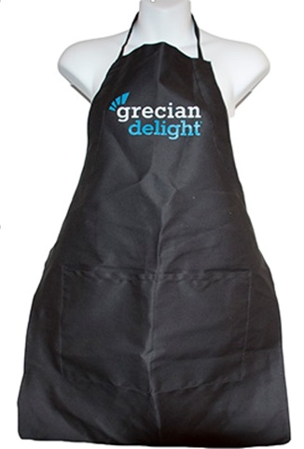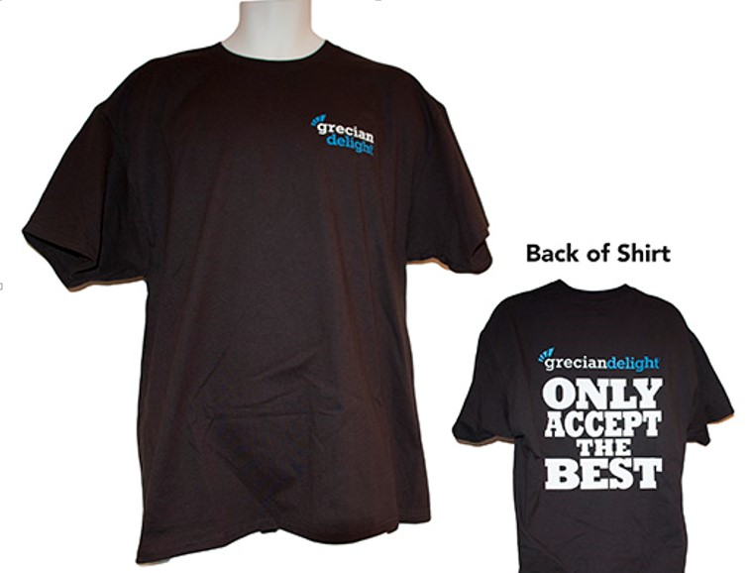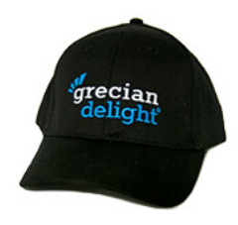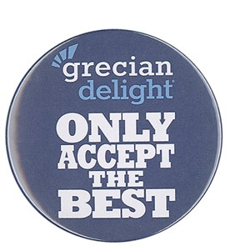

Kronos Branded POS Items
